Kubernetes Lab Guide: Logging, Monitoring & Debugging

🔹 Lab 1: Monitoring Applications

✅ Objective:
Monitor Kubernetes pods and nodes using Metrics Server and visualize metrics with Prometheus and Grafana.

📄 Step 1: Install Metrics Server
kubectl apply -f https://github.com/kubernetes-sigs/metrics-server/releases/latest/download/components.yaml

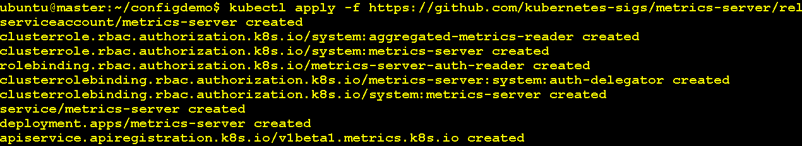

🧪 Step 2: Check Metrics
If you're running in a non-cloud setup (like Minikube, KIND, or bare-metal), you must allow insecure TLS between Metrics Server and Kubelets.

kubectl edit deployment metrics-server -n kube-system

Find the command: section and update like this(It Open VI Editor , so to update press i to insert )
containers:
- name: metrics-server
image: k8s.gcr.io/metrics-server/metrics-server:v0.6.4
args:
- --kubelet-insecure-tls
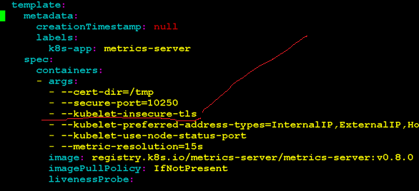
Save and Exit

🧪 Step 3: Restart Metrics Server
When you delete the pod , it will launch it again
kubectl delete pod -n kube-system -l "k8s-app=metrics-server"

🧪 Step 4: Check Metrics server pod is running

kubectl get pods -n kube-system | grep metrics-server

🧪 Step 5: Check Metrics
kubectl top nodes
kubectl top pods

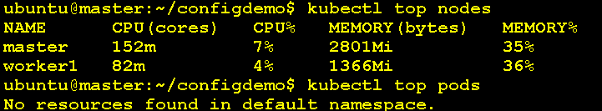

Watch continuously every two second
watch -n 2 kubectl top nodes
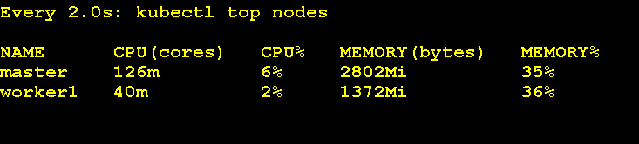

🧪 Step 5: Delete all deployment

kubectl delete -f https://github.com/kubernetes-sigs/metrics-server/releases/latest/download/components.yaml

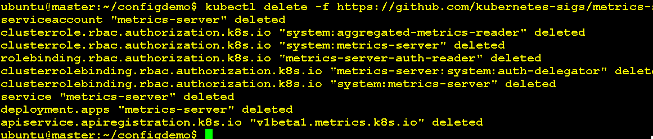

📊 Step 3 (Optional): Install Prometheus + Grafana (using Helm)

curl https://raw.githubusercontent.com/helm/helm/main/scripts/get-helm-3 | bash

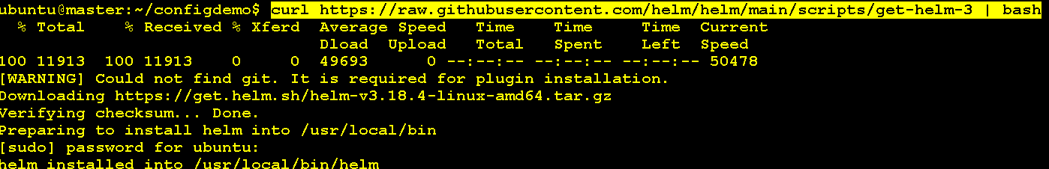
helm repo add prometheus-community https://prometheus-community.github.io/helm-charts
helm repo update
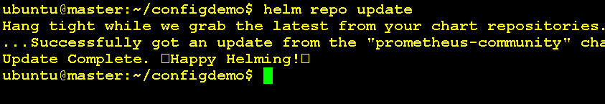
helm install prom-stack prometheus-community/kube-prometheus-stack
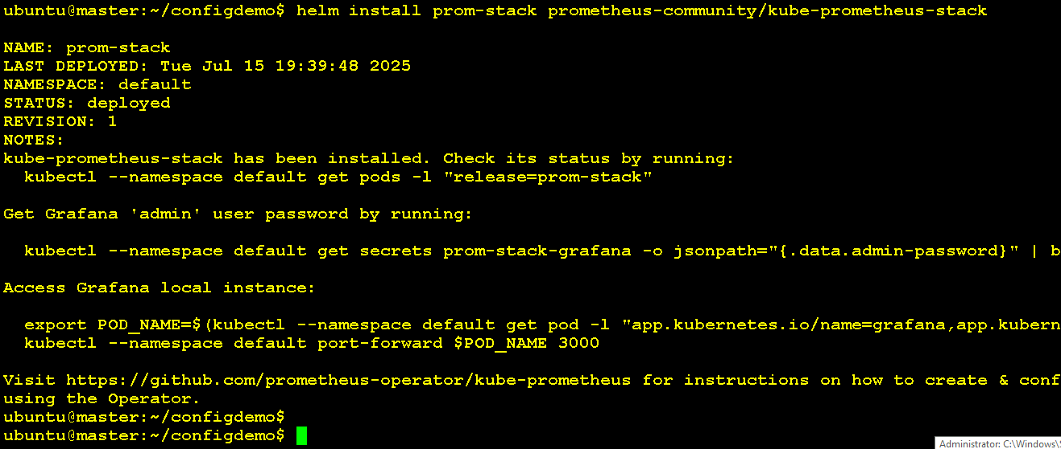

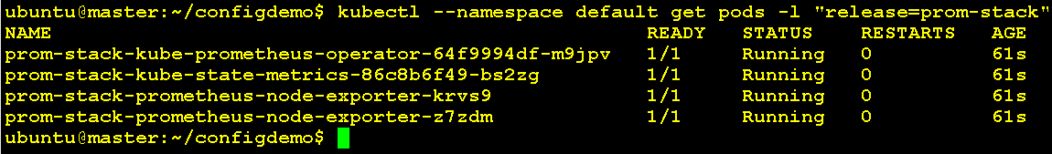

🖥️ Step 4: Access Grafana Dashboard
kubectl port-forward svc/prom-stack-grafana 3000:80
Open browser: http://localhost:3000
Login Username : admin
Password: prom-operator
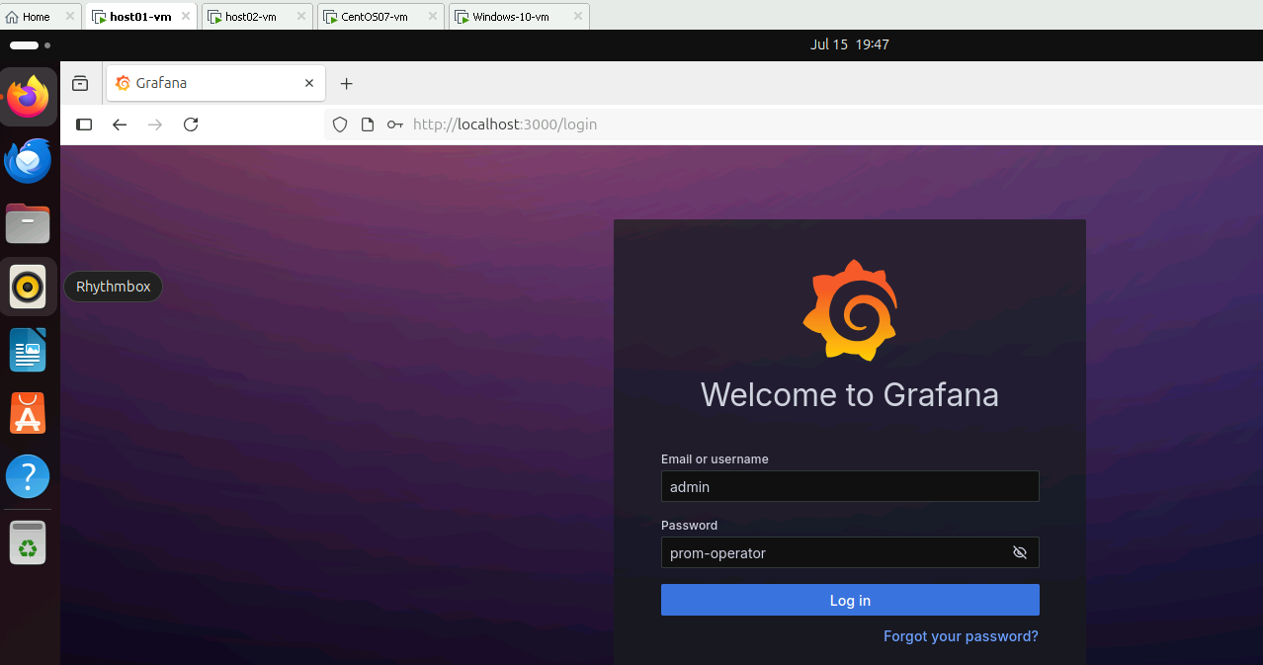

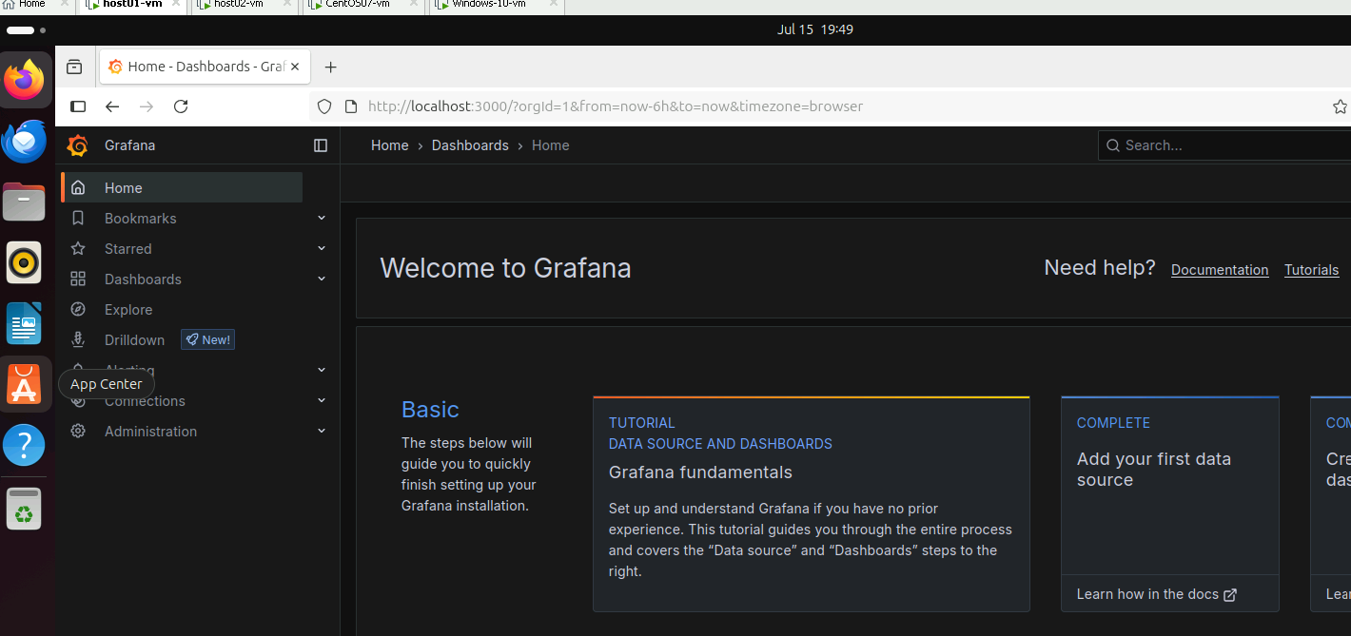

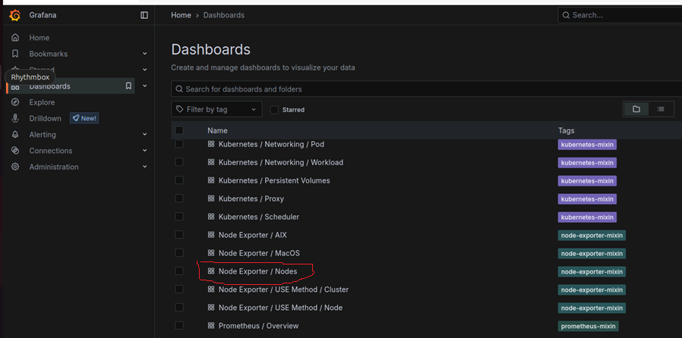

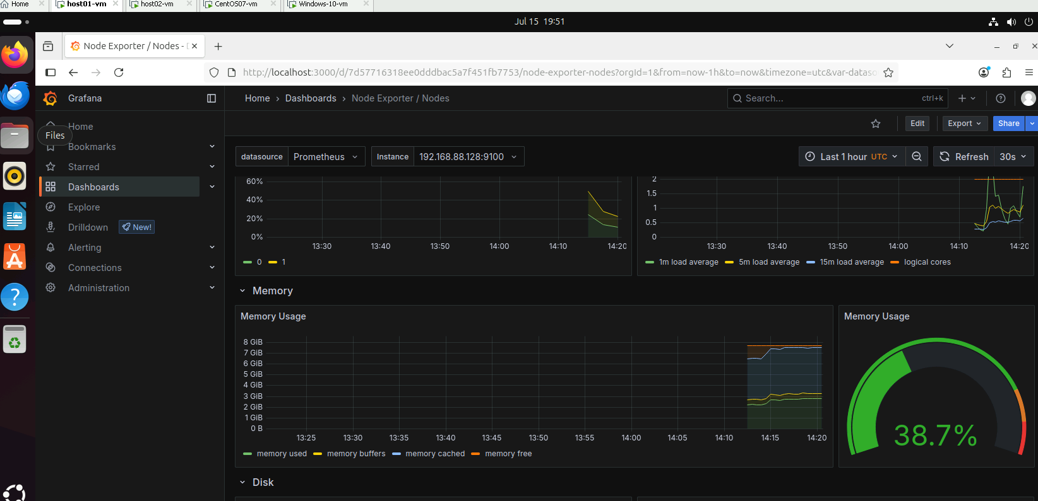
Compute Resource Cluster
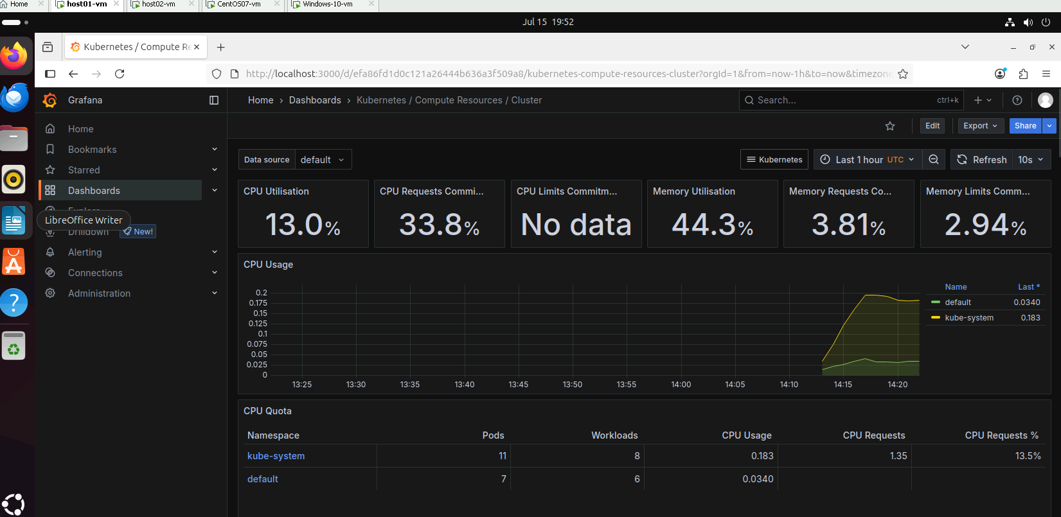

Step 4: Uninstall Prometheus and Grafana

helm uninstall prom-stack

kubectl get pods -n default | grep prom
kubectl get svc | grep grafana

🔹 Lab 3: Debugging Pods

✅ Objective:
Identify and troubleshoot common pod failures using logs and kubectl exec.

❌ Step 1: Create a Crashing Pod
crashpod.yaml
apiVersion: v1
kind: Pod
metadata:
name: crashpod
spec:
containers:
- name: crash
image: busybox
command: ["sh", "-c", "exit 1"]

kubectl apply -f crashpod.yaml

🧪 Step 2: Diagnose the Crash
kubectl get pods
kubectl describe pod crashpod
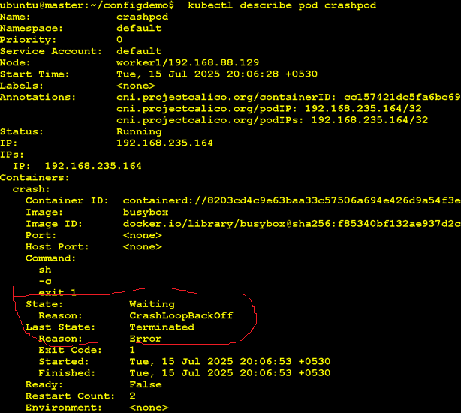

🛠️ Step 3: Exec into a Running Pod
kubectl exec -it logger-pod -- sh

